Project Design Phase-I
Solution Architecture

Date | 28 oct 2026
Team ID
Project Name | Global Olympic Sports Performance Analysis
Maximum Marks | 4 Marks

Solution Architecture:
Solution architecture is a complex process – with many sub-processes – that bridges the gap between business problems and technology solutions. Its goals are to:
- Find the best tech solution to solve existing business problems.
- Describe the structure, characteristics, behavior, and other aspects of the software to project stakeholders.
- Define features, development phases, and solution requirements.
- Provide specifications according to which the solution is defined, managed, and delivered.

Sample Solution Architecture Diagram:
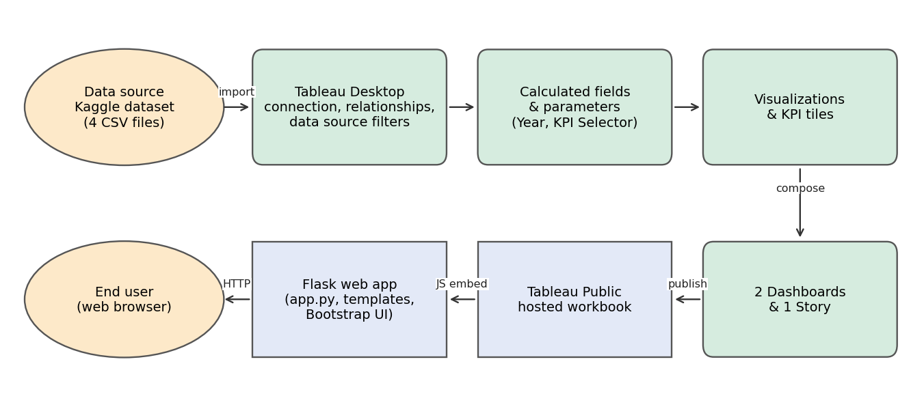

Component Description Table
Component Name | Description / Role in Architecture | Technology Used
Data source | Four Kaggle CSV files: athletes, medal_results, games_summary, alltime_country_rankings | CSV
Data model | Files related on noc_code and year; data source filters remove null medal rows | Tableau Desktop
Calculated fields | Year extraction for the trend line; KPI Selector parameter switching Total, Gold, Silver and Bronze | Tableau calculated field and parameter
Visualisations | Map, line, bar, pie, bubble, donut charts and KPI tiles | Tableau Desktop
Dashboards and story | Two dashboards with filter panels and one multi-scene story | Tableau Desktop
Hosting of workbook | Published workbook with public URLs | Tableau Public
Web application | Serves Home, Dashboard and Story pages and embeds the Tableau Public views | Flask, Jinja templates, Bootstrap, Tableau JavaScript embedding API
User | Views and filters dashboards in a browser | Web browser

